**Cyber Security Essentials | Batch 1 | Day 4 LetsUpgrade Assignment Day 4 | 23rd August 2020**

**Question 1:**

**Find out the mail servers of the following domain :**

**(1) Ibm.com**

**(2) Wipro.com**

**Answer:-**

* **First Open CMD and type nslookup ,**
* **Then type set type=mx for finding mail server.**

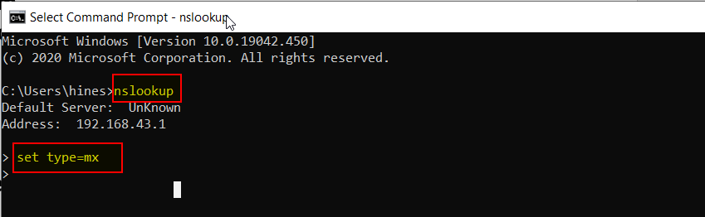

* **Then type the domain name that you want to find that mail server?**

**(1). Ibm.com :-**

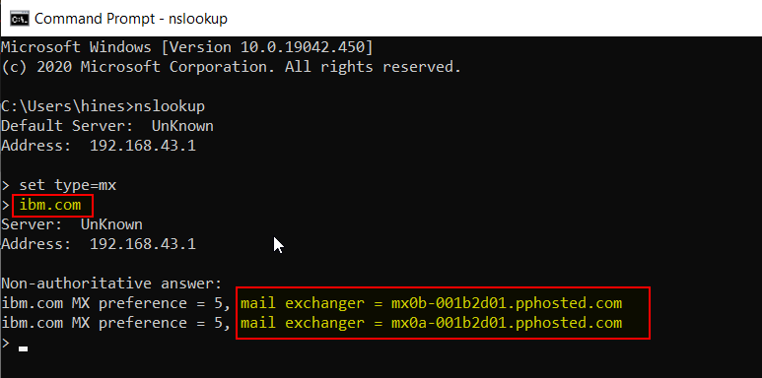

**(3). Wipro.com :-**

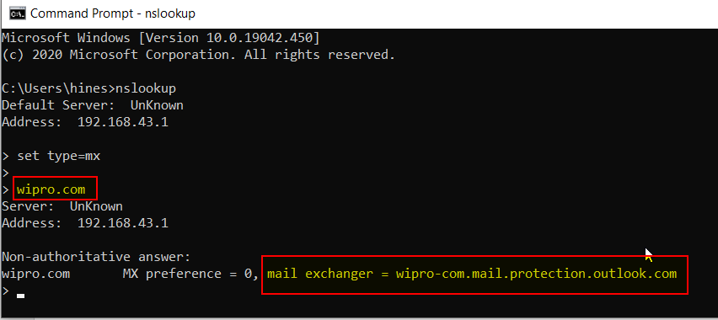

**Question 2:**

**Find the locations, where these email servers are hosted.**

**Answer :-**

**First, in CMD using ping command find IP ADDRESS of theres mailserver.**

**Then using IP Address find Their Location of mail server using this link.**

**Link:-** <https://www.whatismyip.com/ip-address-lookup/>

**1.Location Ibm.com mailserver :-**

1.mx0b-001b2d01.pphosted.com:-

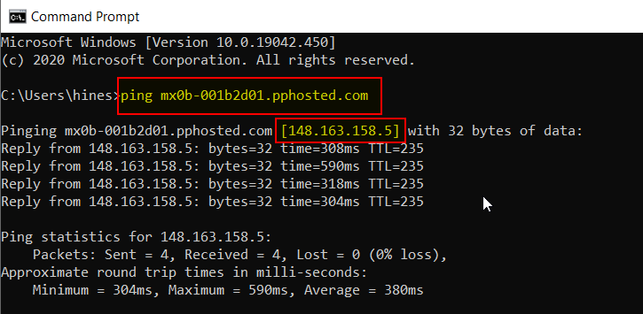

**Then Using IP Address find their location:-** 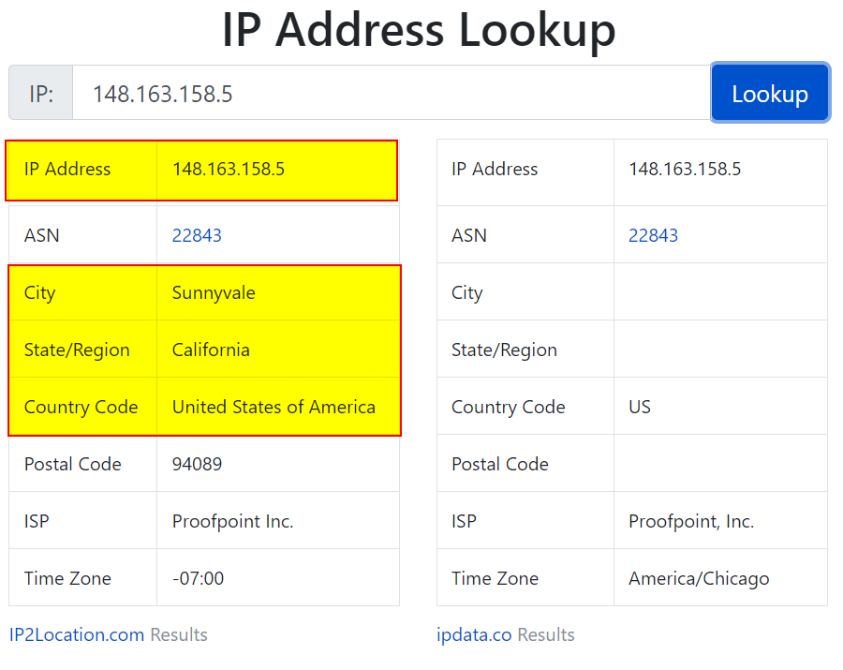

2.mx0a-001b2d01.pphosted.com:-

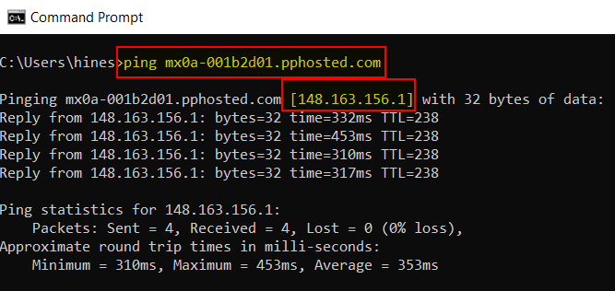

**Then Using IP Address find their location:-**

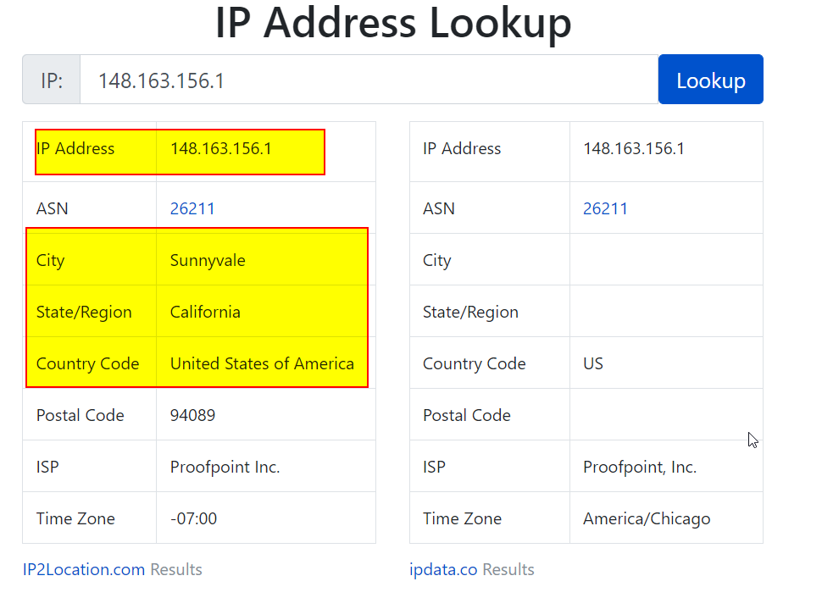

**2.Location wipro.com mailserver :-**

wipro-com.mail.protection.outlook.com:-

**Then Using IP Address find their location:-**

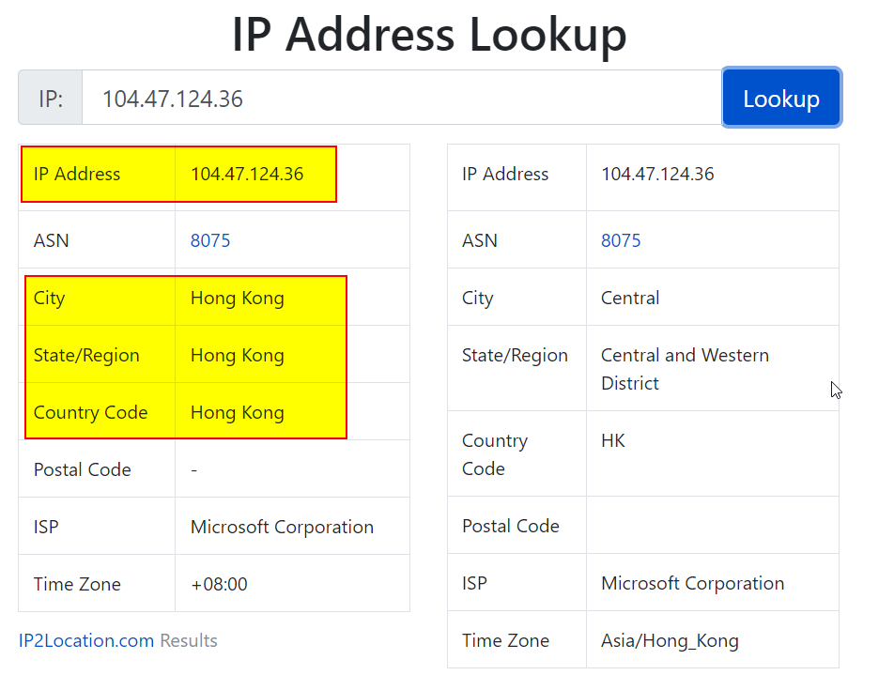

**Question 3:**

**Scan and find out port numbers open 203.163.246.23**

**Answer:-**

**There are no found any open ports of 203.163.246.23 IP Address.All scan ports are filtered.**

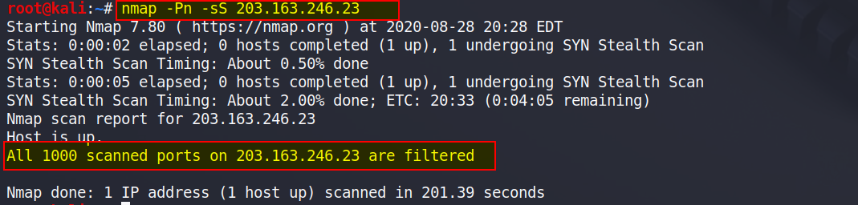

**Note:- All ports scanning take more than 4 hours of time. So, I did not use it.**

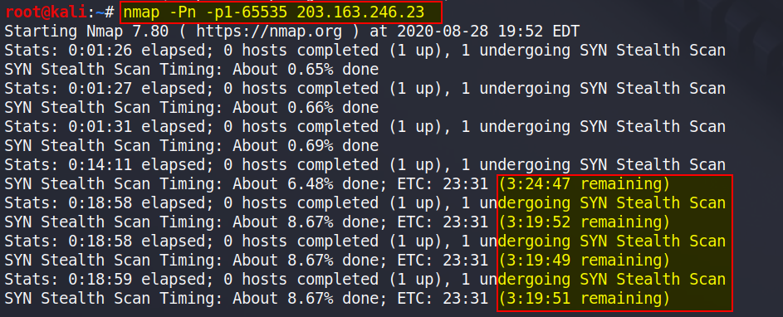

**Question 4:**

**Install nessus in a VM and scan your laptop/desktop for CVE.**

**Answer:-**

**First download and install Nessus in Windows Virtual Machine.**

**Then Open Nessus in browser through the link then put licence key and start services.**

**Next,step go to advance setting**